**Jira Manual testing steps:**

1.Create a project by clicking on the Scrum as shown below.

2.Click on the ‘Select a company-managed project.

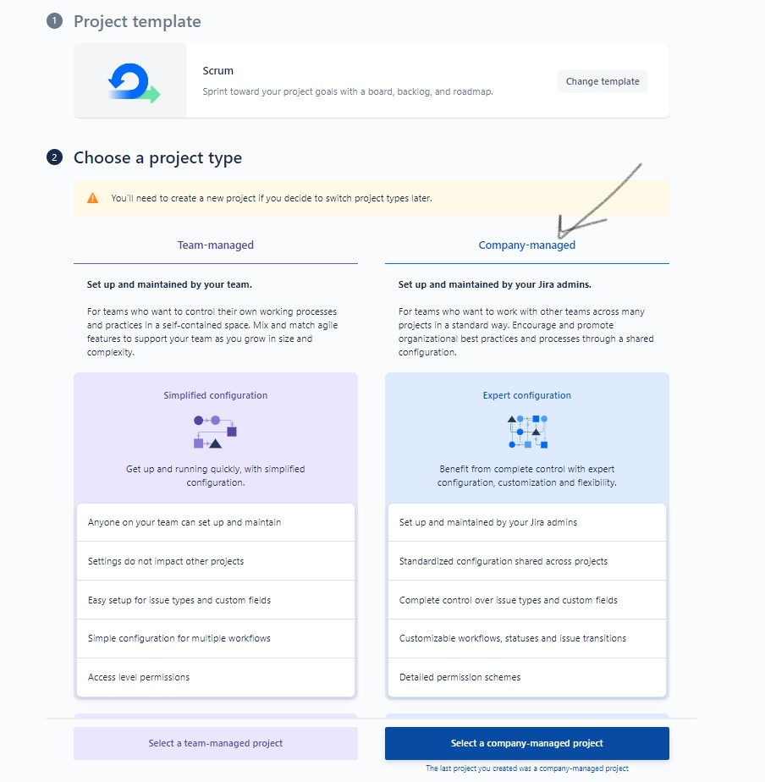

3.Once you create a project, create a version and epic by navigating to the backlog.

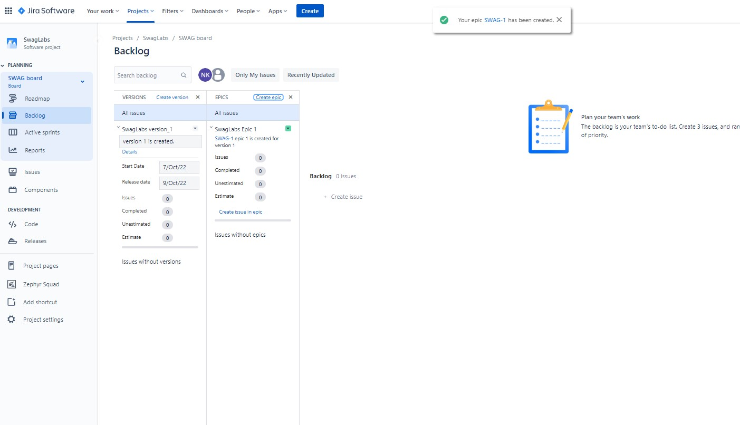

4.Create a user story by clicking on the create button in the home page.

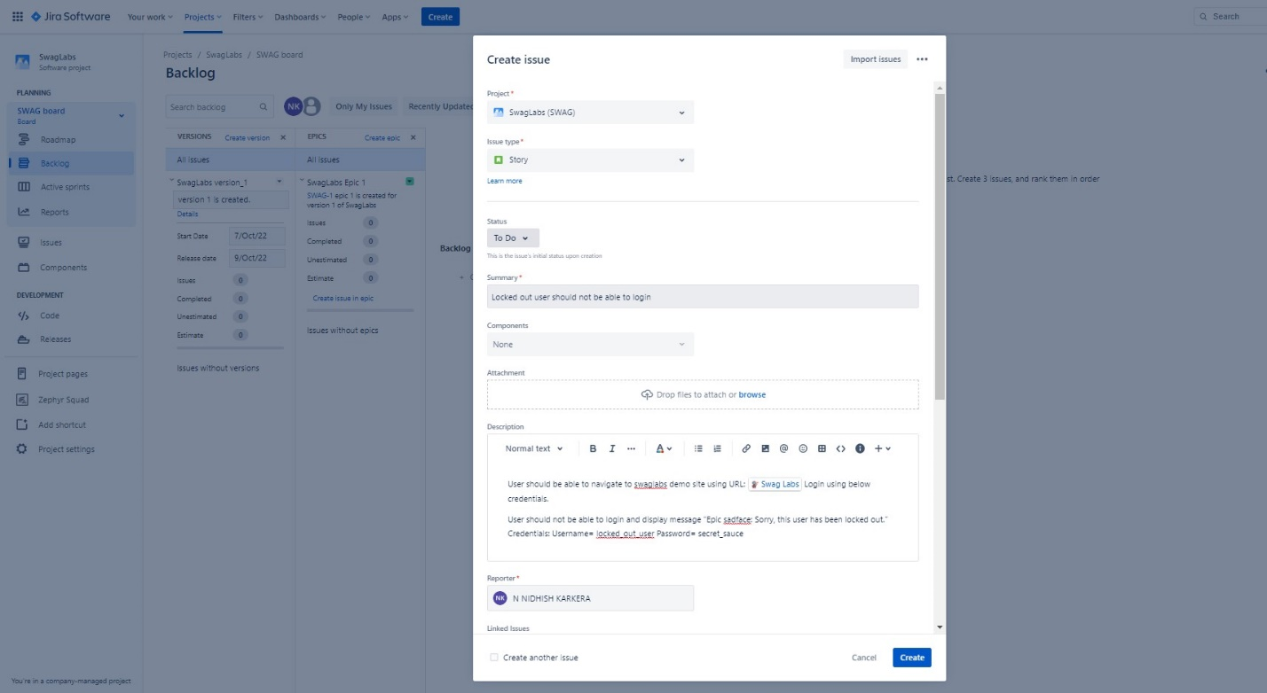

5.After creating the user stories, create the sprint in the backlog and then add all the user stories to the sprint.

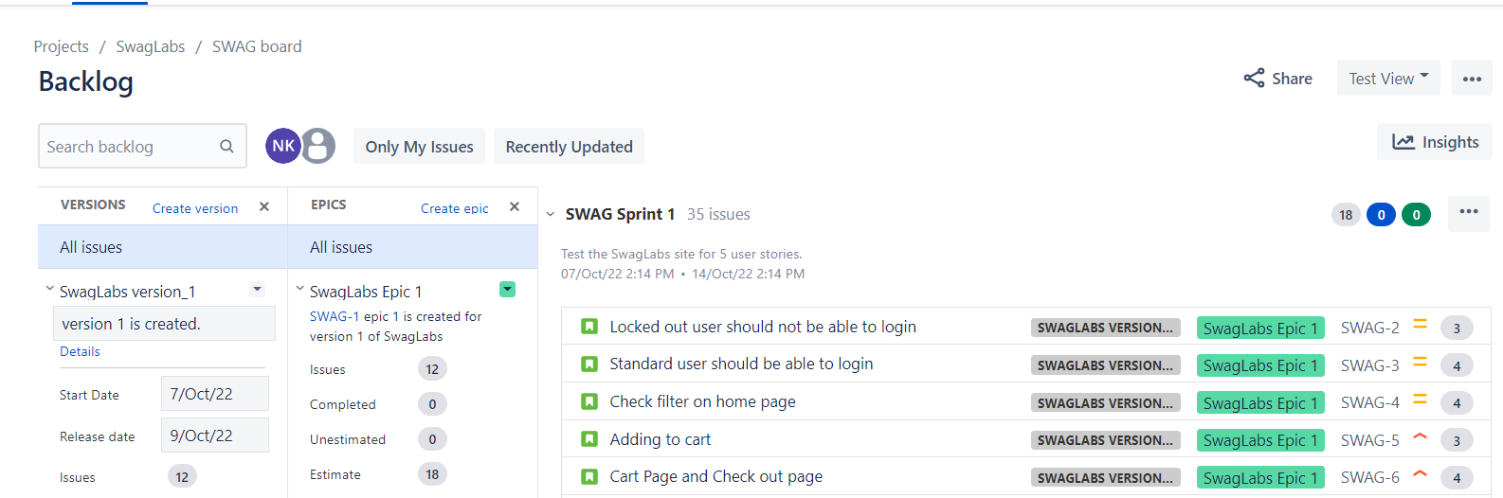

6. Assign the story points to the user stories.

7. Import the test cases by navigating to the Zephyr squad -> Import test case. 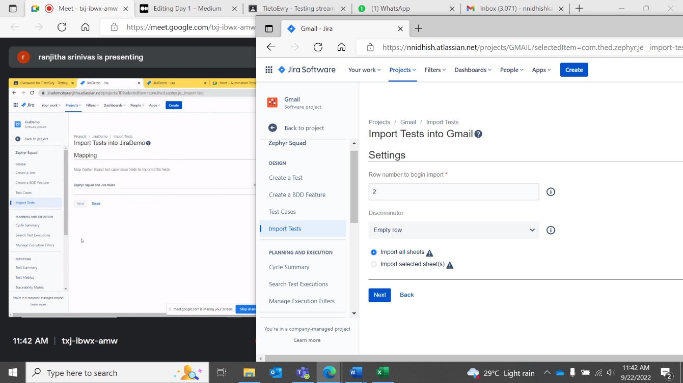

Figure begin from row 2 and choose empty row in the drop down.

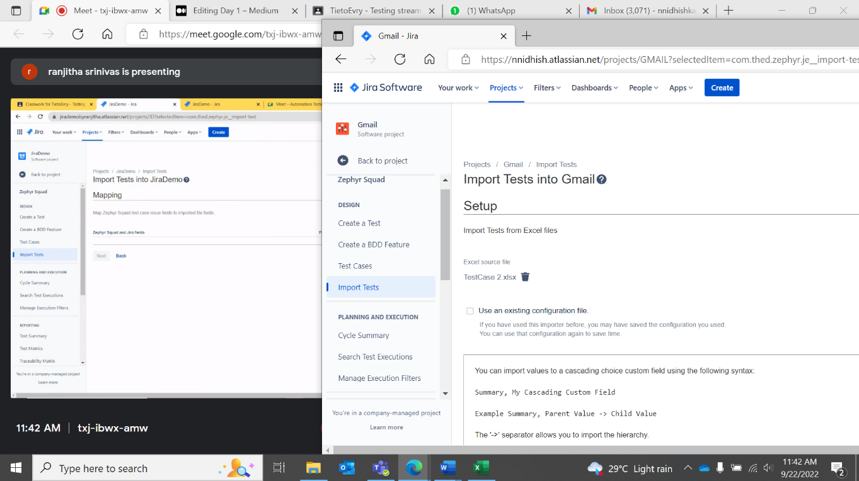

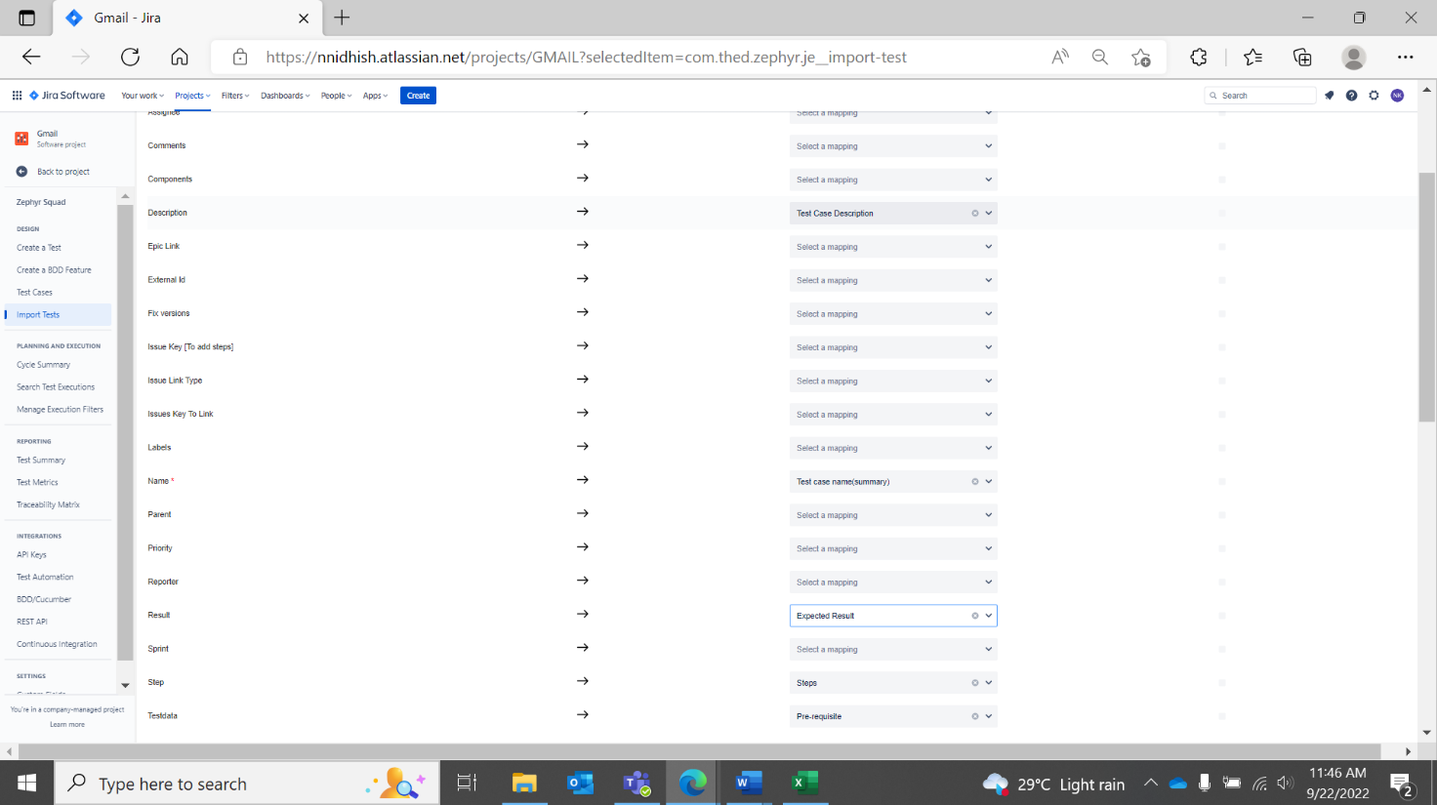

Figure Mapping 5 columns

8.Create the test cycle by clicking on the cycle summary in the zephyr squad.

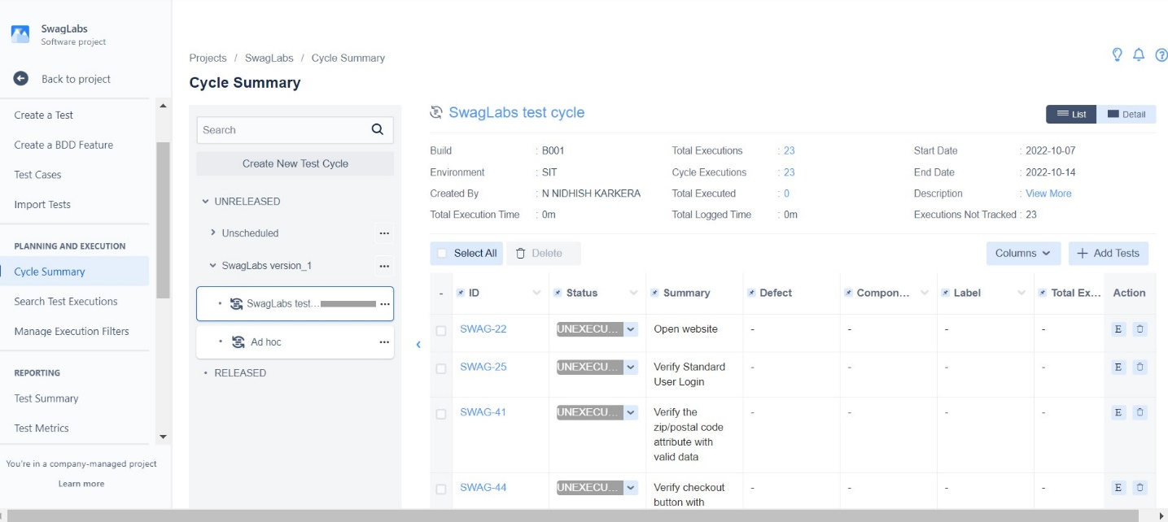

9. Start execution by after starting the sprint. Add attachments if required. And add execution status as pass if all the test steps are passed.

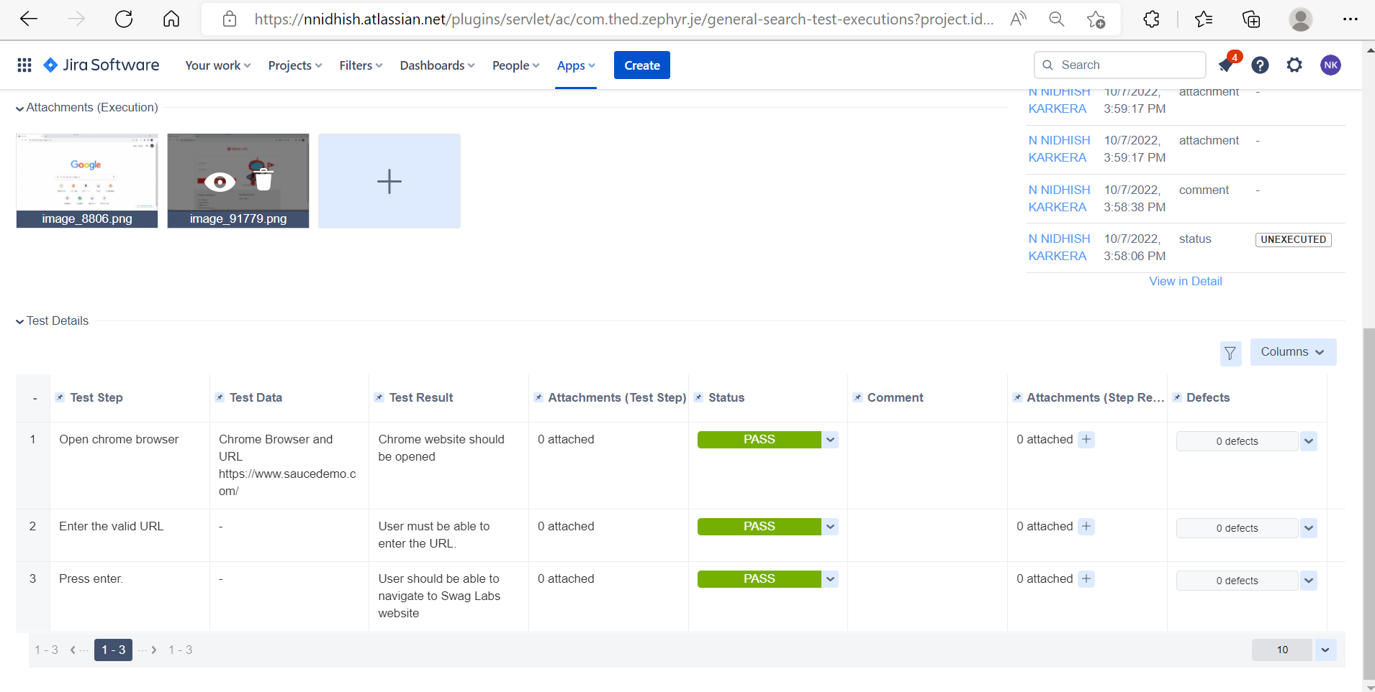

13. similarly ,if test fails, mark status as fail and assign it to developer and add comment , also add attachment. Raise a bug.

